Harry S Truman Incoming Ninth Grade Summer Packet
Harry S. Truman High School uses the Big Ideas Math curriculum. It provides support for parents, teachers and students with Common Core State Standards expectations. Visit the website and explore the online resources to complete the Summer Packet Assignment. Please follow this process:
- Go to bigideasmath.com
- Click on the Green Circle for Student
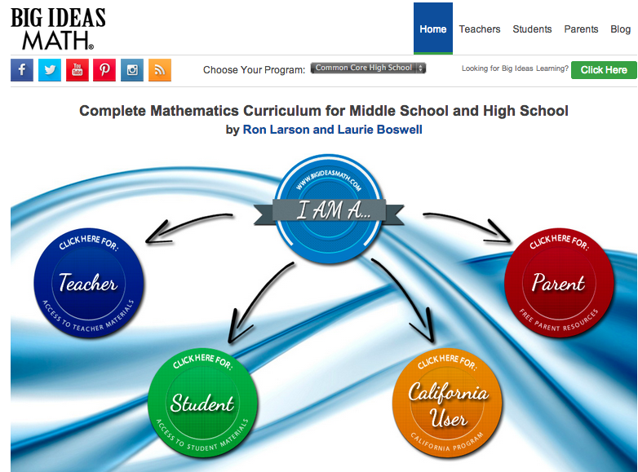

- Scroll Down to the Easy Access Home Edition – No username and password is required.
- Select Common Core High School and click the green Go Button
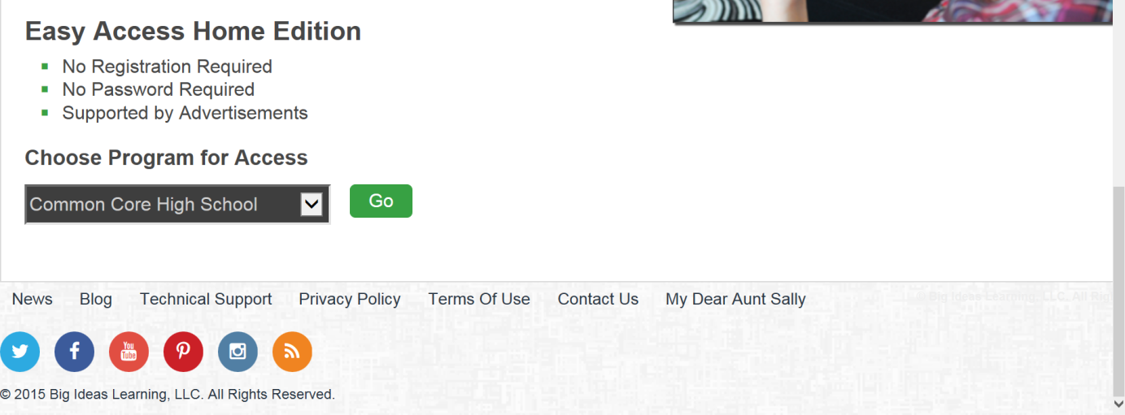

Explore the resources that this website provides.
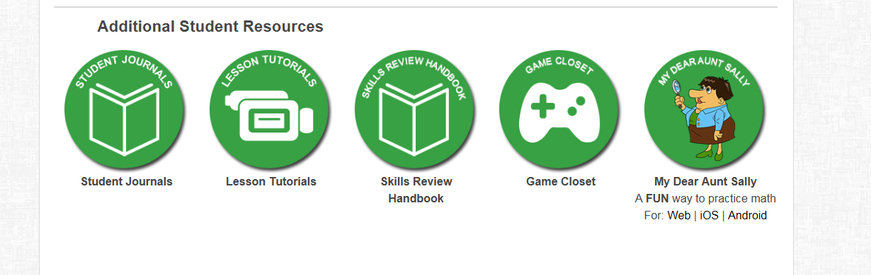

Student Resources | Activity | Task to Complete
Student Journals  Each student will be given a student journal which will account for 50% of your grade. | Under Algebra 1 Student Journals click on and explore at least 5 Chapter journal PDFs. | Write at least three features or headings that are in all chapters.
Lesson Tutorials  Examples and Monitoring Progress examples are explained in both English and Spanish | Watch at least two example videos and at least three Monitoring your progress video. | What is the difference between the two types of videos?  Were these videos helpful?
Game Closet  Games that help you understand mathematical concepts | Review at least three games | Describe your most favorite game from the closet
My Dear Aunt Sally APP | Download the My Dear Aunt Sally APP on your smartphone or tablet.
Skills Review Handbook  You also have access to the Skills Review Handbook. You can print worksheets from this handbook to provide "on level" examples and practice problems for your student and you can check their work with the provided answer sheets. | Find the answer sheet for the skills review sheet that was copied or described below.  Complete the selected attached sheets. | Check your answers and rate each sheet.

Supplies for Math
- Graphing Calculator TI-84 or Wabbit App on Android SmartPhone
- Binder
- Pens, Pencils
To Be Handed in to your Math Teacher for Grading- September 18, 2015
Name _____________________________________ Date: _____________
 | Name of Worksheet | Date Completed | Checked Answer on website  % Correct | Rate each sheet  1. Had difficulty completing even with assistance  2. Completed with assistance  (Write who/ what assisted you)  3. Completed on my own
1 | Equivalent Fractions and Simplifying Fractions |  |  | 1 2 3
2 | Writing Fractions, Decimals and Percents |  |  | 1 2 3
3 | Operations with Integers |  |  | 1 2 3
4 | Square Roots |  |  | 1 2 3
5 | Evaluating Algebraic Expressions |  |  | 1 2 3
6 | Simplifying Algebraic Expressions |  |  | 1 2 3
7 | Order of Operations |  |  | 1 2 3
8 | The Distributive Property |  |  | 1 2 3
9 | Polynomials |  |  | 1 2 3
10 | Solving Linear Equations |  |  | 1 2 3
11 | The Coordinate Plane |  |  | 1 2 3
12 | Slope of a Line |  |  | 1 2 3
13 | Graphing Linear Functions |  |  | 1 2 3
14 | Bar Graphs and Line Graphs |  |  | 1 2 3

